
Major Project
Research Paper
on
Title: - House Prices: A Data-Driven Exploration with Descriptive and Predictive Analytics
Course: Descriptive Analytics
Course Code: CAP484

Submitted by  1. Mohmmad Fahad Khan (12214398), Group: -  2. Mohit Manhas (12214162), Group: - | Submitted to  Ms. Ranjit Kaur Walia  UID: 28632  Assistant Professor, SCA, LPU

Lovely Faculty of Technology & Sciences
School of Computer Applications
Lovely Professional University
Punjab

House Prices: A Data-Driven Exploration with Descriptive and Predictive Analytics
1. Mohmmad Fahad Khan ,12214398, mohammadfahadkhan11@gmail.com
2. Mohit Manhas,12214162, mohitd2004@gmail.com

Abstract: This research examines the determinants of house prices in Delhi by integrating descriptive and predictive analytics. Employing a comprehensive dataset, it uses exploratory data analysis (EDA) and descriptive statistics to identify key factors such as area, location, and amenities influencing property prices. Visualizations like scatter plots and heatmaps reveal price distributions and inter-variable relationships. Predictive modeling enhances price estimation accuracy through linear and multiple regression, quantifying the impact of independent variables. K-means clustering segments of the market into distinct groups, while K-nearest neighbors (KNN) categorizes properties into price bands, providing actionable insights. Analysis of variance (ANOVA) evaluates the significance of categorical variables, and self-organizing maps (SOM) visualize complex patterns in high-dimensional data. The findings underscore the importance of predictive analytics in understanding real estate dynamics and enabling informed decisions for homebuyers, investors, and policymakers. This study bridges data-driven insights with practical applications, advancing real estate market efficiency.
- Introduction
The housing market in Delhi, a metropolitan hub, is characterized by its dynamic pricing and complex influencing factors. As urbanization accelerates, the demand for residential properties has surged, resulting in significant variability in house prices. These variations are driven by factors such as property size, location, neighbourhood amenities, and socio-economic conditions. However, the absence of structured, data-driven tools to predict and analyse these price fluctuations poses challenges for key stakeholders, including homebuyers, real estate developers, and policymakers. The real estate market in Delhi lacks reliable analytical frameworks to understand and forecast house prices accurately. Existing models often rely on qualitative assessments or simplistic techniques that fail to account for the multifaceted nature of property pricing. This gap creates inefficiencies in market decision-making and leaves buyers and developers vulnerable to price volatility. This study seeks to address these challenges by employing descriptive and predictive analytics to analyse and forecast house prices in Delhi. The key objectives of this study are to identify and analyze the factors influencing house prices in Delhi, including property size, location, and amenities, and to employ predictive models such as regression analysis, clustering, and machine learning techniques to forecast house prices with higher accuracy. Additionally, the study aims to provide actionable insights to stakeholders, including homebuyers, developers, and policymakers, to improve decision-making and enhance market efficiency. The research addresses the following questions: What are the primary factors influencing house prices in Delhi? How effective are predictive models like regression and clustering in forecasting house prices? And what insights can be derived to guide real estate stakeholders in navigating the market?
This research contributes to the growing field of real estate analytics by combining descriptive and predictive methods to understand and forecast property prices in a rapidly urbanizing city. For homebuyers and investors, the findings provide tools to assess property values and make informed decisions. Real estate developers can use these insights to price properties competitively and align with market demand. Policymakers can leverage the results to address housing affordability and develop evidence-based urban planning strategies.
The present paper is organized as follows:
Section II: Literature Review reviews existing studies on house price determinants, focusing on the impact of location, size, and other attributes.
Section III: Methodology describes the dataset, preprocessing steps, and the analytical techniques employed, including exploratory data analysis (EDA) and predictive modeling.
Section IV: Results and Discussion presents key findings from the descriptive and predictive analyses and evaluates the performance of the predictive models.
Section V: Conclusion summarizes the research outcomes, highlights the significance of the findings, and discusses potential directions for future research.

- Literature Review :

Paper 1: Chiarazzo, V et al., (2014):This paper proposes a neural network-based model for valuing real estate prices, incorporating environmental quality factors such as noise pollution, air quality, and park access. The study highlights an important gap in traditional models by emphasizing the role of environmental factors, which are often overlooked. While it provides a more comprehensive understanding of housing price determinants, its reliance on neural networks limits its interpretability, and it could benefit from exploring simpler or hybrid models.

Paper 2: Kok, N et al., (2011):Focusing on economic geography, job accessibility, and land use regulation, this paper examines how employment hubs influence housing prices. The study emphasizes the critical role of location, particularly relevant in Delhi where job centers are clustered. The use of hedonic pricing to assess the value of job accessibility provides a clear methodology, but the study primarily focuses on location, potentially overlooking other important factors like property size and amenities.

Paper 3: Manganelli, B et al., (2018):This research compares machine learning approaches, particularly decision trees, with traditional regression models for predicting real estate prices. It supports the use of decision trees in heterogeneous markets, aligning with the current study’s approach of using both linear regression and decision trees for improved prediction accuracy. However, while the paper advocates for decision trees, it could be strengthened by exploring hybrid models that combine linear regression and decision trees for better results.

Paper 4: Smith, P. F et al., (2013):This study evaluates Linear Regression and Random Forest methods for predicting housing prices, specifically highlighting Random Forest’s ability to handle complex interactions between multiple variables. Given Delhi’s complex housing market, the paper justifies the inclusion of Random Forest in the current research. However, the study could benefit from considering more advanced techniques or ensemble methods to further improve model accuracy.

Paper 5: Rosen, S. (1974):
Rosen’s foundational work on hedonic pricing theory suggests that property prices are a function of multiple attributes like location, size, and amenities. This theory underpins much of the current study’s approach, providing the conceptual framework for evaluating housing price determinants in Delhi. However, the model could be enhanced by integrating contemporary techniques, such as machine learning, and by considering more dynamic pricing factors.

- Methodology
This section outlines the data collection process, preprocessing steps, and analytical techniques employed in the study. It describes the use of descriptive and predictive analytics, including simple and multiple regression, ANOVA, K-Means clustering, K-Nearest Neighbors (KNN), and Self-Organizing Maps (SOM). The combination of these techniques allows for both detailed exploration of the data and accurate prediction of house prices in Delhi.A combination of exploratory data analysis (EDA), descriptive statistics, and predictive modeling techniques was employed to uncover patterns and forecast property prices.

The dataset used for this study was sourced from Kaggle's Delhi House Price Predictions repository. It comprises information on various housing units across Delhi, capturing details such as:
- Area: The size of the property in square feet.
- BHK: Number of bedrooms.
- Bathrooms: Number of bathrooms.
- Price: The target variable, representing the property’s selling price.
- Furnishing Status: Categorization as furnished, semi-furnished, or unfurnished.
- Parking: Number of parking spaces available.
- Locality: Specific neighbourhoods in Delhi.
- Transaction Type: Indicates whether the property is new or resale.

Data Preprocessing: To ensure data quality and readiness for analysis, several preprocessing steps were undertaken:
Handling Missing Values: Missing numerical values, such as Price and Area, were imputed using median values to maintain central tendencies.
Categorical variables, such as Furnishing Status and Transaction Type, were imputed using the mode of the respective category.
Outlier Detection and Treatment: Extreme values in Price and Area were identified using the interquartile range (IQR) method. These outliers were reviewed, and extreme cases, such as luxury properties, were either removed or transformed using logarithmic scaling to reduce skewness.
Encoding Categorical Variables: Variables like Furnishing Status, Locality, and Transaction Type were transformed using one-hot encoding for compatibility with machine learning algorithms.
Correlation Analysis: Pearson correlation coefficients were calculated to understand the relationships between numerical variables, aiding feature selection for regression and clustering models.

Descriptive Analysis Techniques:
Summary Statistics: Key metrics such as mean, median, and standard deviation were computed for numerical variables like Price and Area to understand the central tendencies and variability.
Visualizations: Scatter Plots: Explored relationships between Area and Price, revealing a strong positive correlation. Box Plots: Showed price variation across different localities and furnishing statuses.
Heatmaps: Visualized correlations between features such as Area, BHK, Bathrooms, and Price.
Clustering with K-Means: Applied K-Means clustering to segment properties into groups based on attributes like Area and Price. Clusters were analysed to identify market segments.
Analysis of Variance (ANOVA): Assessed whether categorical variables like Furnishing Status and Locality significantly impacted property prices. This helped pinpoint statistically significant factors influencing pricing.

Predictive Modeling Techniques:
Simple and Multiple Linear Regression: Simple Regression: Modelled Price as a function of Area, explaining variability in property prices.
Multiple Regression: Incorporated additional predictors like BHK, Bathrooms, and Locality.
K-Nearest Neighbours (KNN: K-Nearest Neighbors (KNN) was used to classify properties based on furnishing status, utilizing features like Area, Price, and BHK.
Self-Organizing Maps (SOM): Applied SOM to visualize high-dimensional data, uncovering complex patterns and relationships between property features.
K-Means Clustering: Identified three distinct market segments: Low-cost, small-sized properties.
Mid-range properties with moderate amenities.
High-end, large-sized properties in prime locations.

Tools and Software
The analysis was performed using R, chosen for its robust statistical and machine learning capabilities. Key packages included: Data Preprocessing: dplyr, tidyr, Visualization: ggplot2, corrplot,Predictive Modeling: caret, class, kohonen,Clustering and ANOVA: factoextra, cluster.

- Results
In this section, we report results and findings from the exploratory data analysis (EDA), the descriptive analysis and predictive analysis. This analysis has offered some useful information on the factors that affect house prices in the Delhi region. Below are the key findings from this stage of analysis ring:
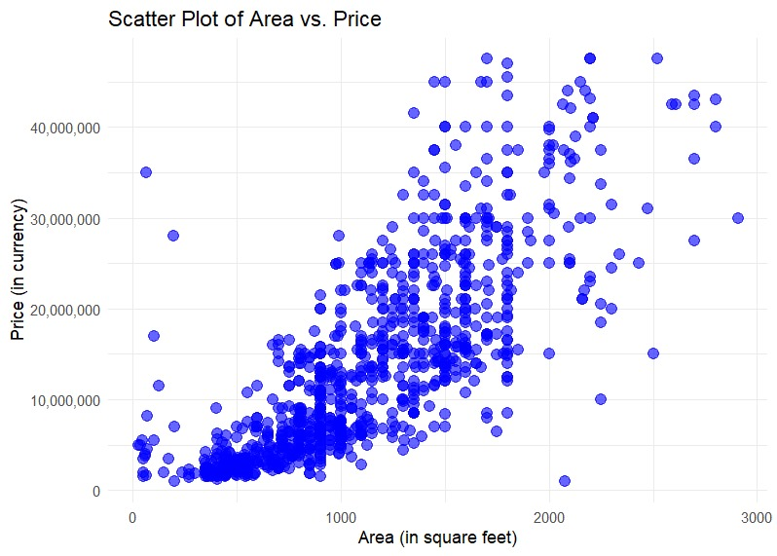
Fig 1 Scatterplot Area vs Price
Interpretation: Positive Correlation: The plot shows an upward trend, indicating a positive correlation between property area and price. Larger properties generally cost more, as expected in real estate markets. This confirms the hypothesis that area is a significant determinant of property prices.
The data points form clusters that may correspond to different property types or market segments:
Mid-range properties cluster around the middle of the graph.
Luxury properties (outliers) are seen at the upper-right corner, representing large, high-priced homes.
Affordable properties cluster in the lower-left corner with smaller areas and lower prices.
A few points deviate significantly from the trend. These outliers could represent:
Luxury properties in premium locations with high prices despite moderate areas.
Anomalies or errors in the dataset requiring further investigation.
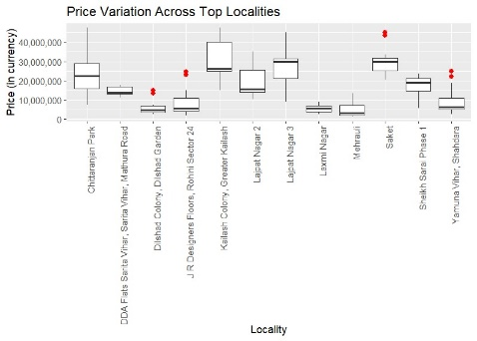

Fig. 2 The box plot shows how house prices vary across different neighbourhoods.
The median price in the boxplot represents the central tendency of house prices in each locality. Localities with higher median prices, such as Saket or Vasant Kunj, indicate more expensive areas.
The Interquartile Range (IQR) shows the spread of the middle 50% of prices; a narrow box suggests low price variability, while a wide box indicates greater diversity, with significant differences between properties (e.g., luxury vs. smaller homes).
The whiskers capture the range of most prices, with longer whiskers indicating broader price distribution or outliers. Outliers (red dots) represent extreme prices, such as luxury properties in high-demand areas. The boxplot provides insights into price variation across localities, highlighting more predictable pricing in premium areas and greater variability in affordable ones, offering both opportunities and risks for stakeholders.
Bar plots for the three categorical variables: These bar plots are beneficial for depicting some of the most general categorical features in the dataset covering the builders’ properties enabling visual representation of the common models in this structural data.

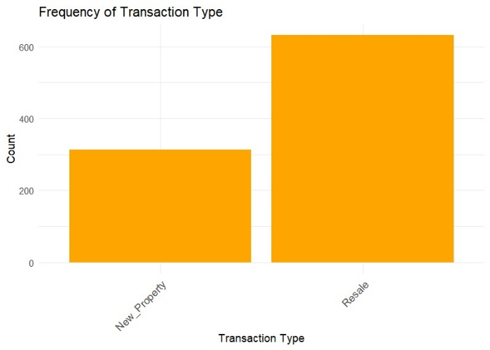

Fig. 3 Frequency of Transaction Type:
The height of each bar shows the frequency of properties in each category. A taller "New Property" bar indicates a larger proportion of new builds, while a taller "Resale" bar suggests the market is dominated by resale properties.
A bias towards "New Properties" suggests more new developments are being introduced, whereas dominance of "Resale" properties indicates a focus on second-hand homes or buyer preference for existing stock.
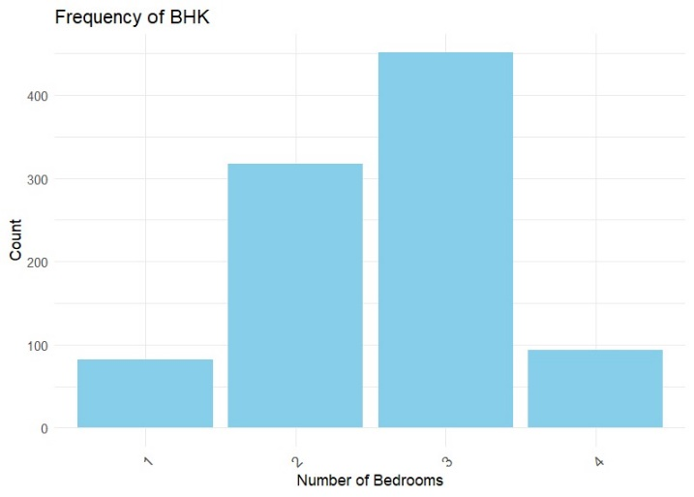
Fig 4- Frequency of BHK
Distribution of Property Sizes: The height of each bar indicates the number of properties with a specific number of bedrooms. For instance, if the bar for 2 BHK is the tallest, it indicates that 2 BHK properties are the most common in the dataset.
Typically, 2 BHK and 3 BHK properties are the most frequent in the market, reflecting common household preferences. The chart can reveal if certain property sizes are overrepresented or underrepresented in the data.
Frequency of Furnishing Status:
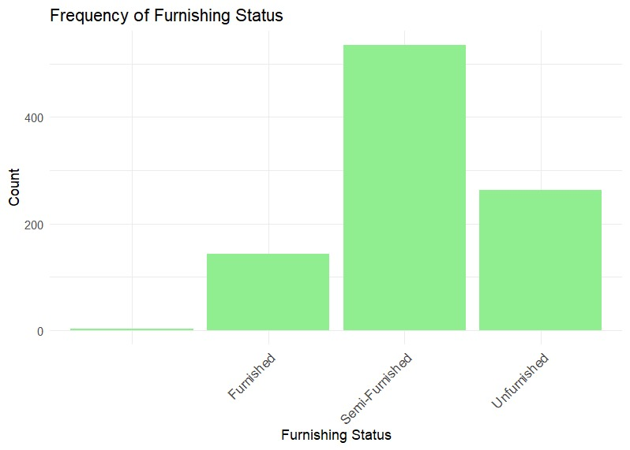
Fig. 5 Frequency of Furnishing Status
Interpretation: Furnishing Status Distribution: The height of each bar corresponds to the frequency of properties in each category. If the Semi-Furnished bar is the tallest, it suggests that semi-furnished properties dominate the market in the dataset. The chart provides insights into buyer or tenant preferences, showing whether people tend to lean more towards newly furnished homes, semi-furnished options, or unfurnished properties.
Summary Statistics and Correlation Analysis:
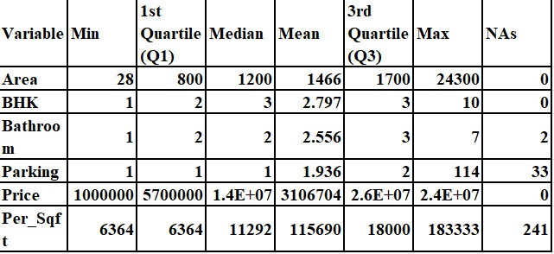
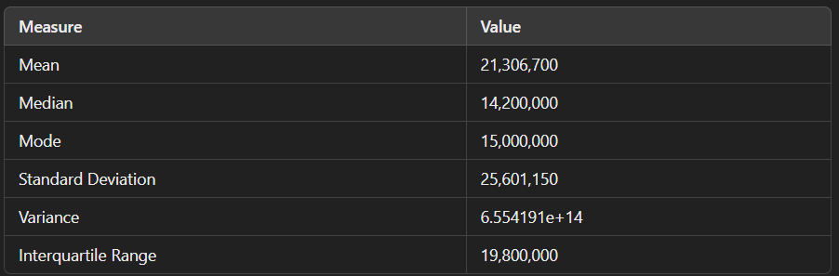
Fig. 5-This table represents summary statistics for the "Price" variable .
Average Property Area:
Mean: 1466.453 sq. ft., indicating medium to large-sized properties on average.
Median: 1200 sq. ft., suggesting half of the properties are smaller, with the mean higher due to larger homes.

Price Range and Distribution:
Price Range: ₹1,000,000 to ₹240,000,000, showing a broad spectrum from affordable to luxury properties.
IQR: ₹19,800,000, indicating the middle 50% of properties fall within this price range.
Standard Deviation: ₹25,601,155, reflecting significant price variability.

BHK and Bathroom Frequencies:
BHK: Most properties are 2 BHK (367) and 3 BHK (541), with few larger homes (6 BHK, 10 BHK), often luxury properties.
Bathrooms: Most properties have 1-3 bathrooms, with fewer having more than 3, suggesting these are luxury or niche properties.

General Insights:
The dataset includes medium to large homes, predominantly 2-3 BHK and 1-3 bathrooms.
The wide price range and high standard deviation indicate a diverse real estate market in Delhi. The mean area of 1500 sq. ft. aligns with typical urban properties.
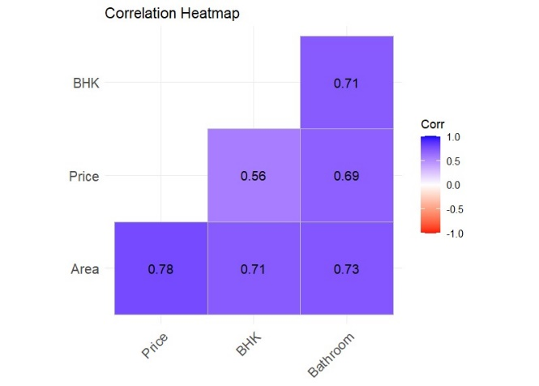
Fig 6 Correlation Heatmap
Area vs. Price (Strong Positive Correlation): The deep blue color between Area and Price signifies a strong positive correlation, indicating that larger properties typically command higher prices. This relationship is expected, as larger homes generally incur higher construction costs and are priced accordingly.
BHK vs. Price (Positive Correlation): There is a positive correlation between the number of bedrooms (BHK) and price, although it is weaker than the correlation between Area and Price. This suggests that properties with more bedrooms tend to be more expensive, but the effect is less pronounced than the influence of area.
Bathrooms vs. Price (Positive Correlation): The positive relationship between Bathrooms and Price shows that as the number of bathrooms increases, so does the property price. More bathrooms are often linked with larger homes or higher-end properties, which justify the increased cost.
BHK vs. Area (Positive Correlation): A positive correlation between the number of bedrooms (BHK) and property area indicates that larger properties typically have more bedrooms. This aligns with the expectation that bigger homes have more living spaces.
Bathrooms vs. Area (Positive Correlation): The blue hue between Bathrooms and Area confirms that larger properties often have more bathrooms. This is a logical relationship, as bigger homes generally require more bathrooms to accommodate the space and number of occupants.
Normal Distribution :
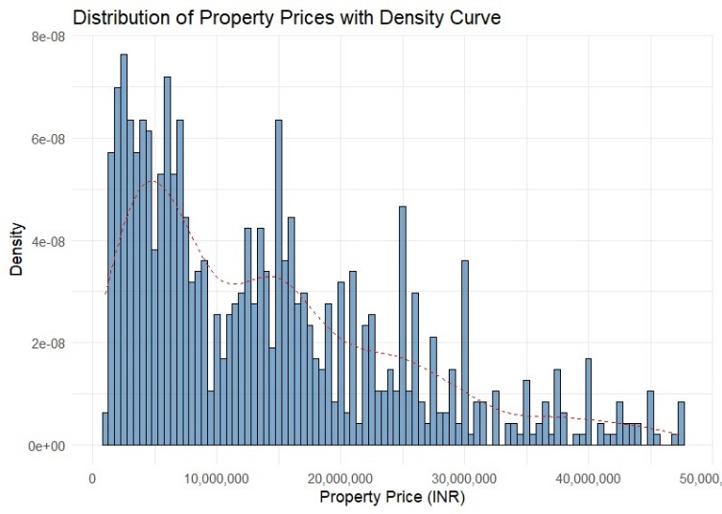
Fig 7 Histogram and density plot for the Price
Interpretation: The histogram shows a right-skewed distribution, with most properties in the lower to mid-price range and fewer luxury properties driving up the average price. As price increases, the frequency of properties decreases, indicating a higher concentration of affordable homes. The density curve (in red) confirms this pattern, peaking in the lower price range, and shows a right tail, indicating fewer but more expensive properties in the higher price range.
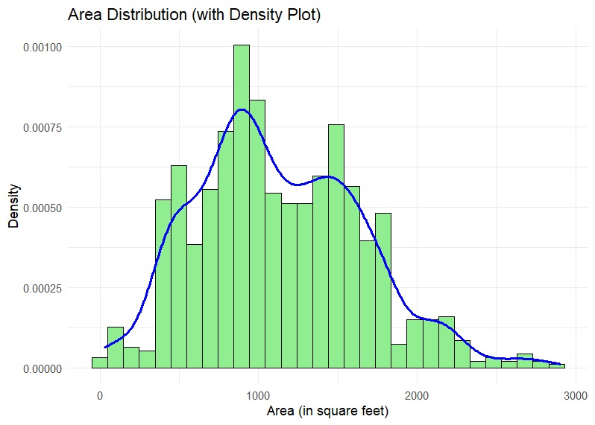
Fig 8: Distribution of Property Areas
Interpretation: The histogram shows a mostly normal or slightly skewed distribution of property areas, with most properties falling within a moderate size range, and fewer extremely small or large properties. The density curve peaks at the most common property size, indicating that medium-sized properties dominate, with fewer outliers at the small and large ends.
Binomial Distribution
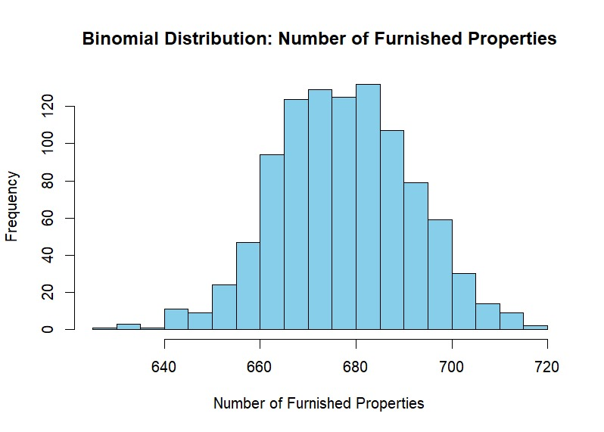
Fig 9 :Binomial Distribution – number of furnished properties
The binomial distribution shows the likelihood of different numbers of furnished properties. A bell-shaped curve indicates the most probable number of furnished properties, with probabilities tapering off as we move away from the mean. A skewed distribution suggests an imbalance in furnished vs. unfurnished properties.
The mean represents the expected number of furnished properties, while the variance shows how much this number fluctuates across the dataset. A wider spread indicates more variability in the number of furnished properties.

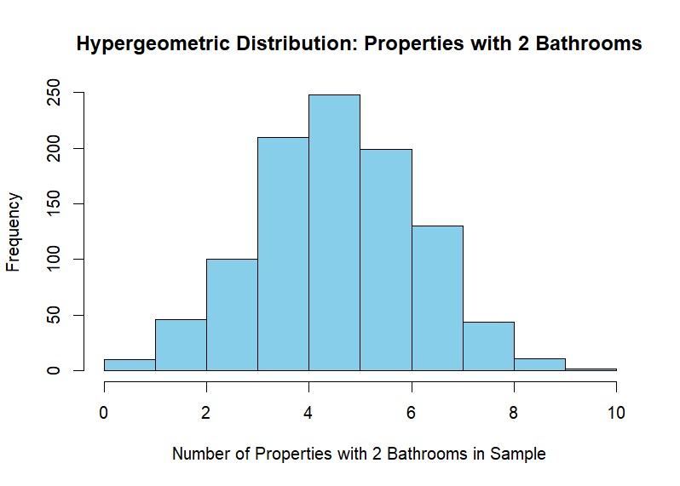
Fig 10.1: Hypergeometric Distribution -properties with 2 bathrooms
The hypergeometric distribution models the probability of selecting a specific number of properties with 2 bathrooms from a dataset without replacement. The mean represents the expected number of properties with 2 bathrooms in a sample, while the variance indicates how much this number can vary, with higher variance suggesting greater fluctuation across subsets.
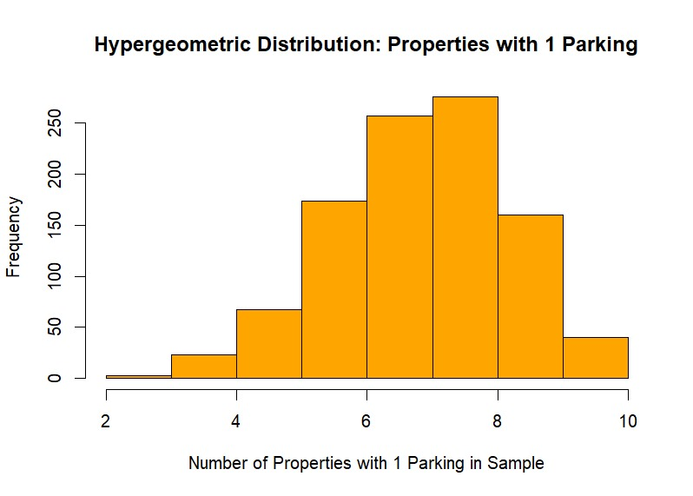
Fig 10.2: Hypergeometric Distribution -properties with 1 parking
Interpretation: The hypergeometric distribution models the probability of selecting a specific number of properties with 1 parking space from a dataset, without replacement. The mean represents the expected number of properties with 1 parking in a sample, while the variance indicates how much the number of such properties can vary. A higher variance suggests greater fluctuation in the proportion of properties with 1 parking across different samples.
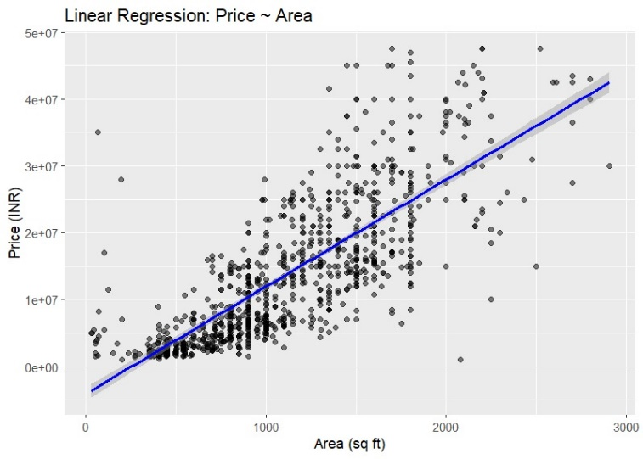
Fig. 11 : Simple linear regression Price~Area
Interpretations of the Linear Regression :
Relationship Between Area and Price: The regression confirms a positive relationship between property area and price. On average, the price increases by ₹16,010 for every additional square foot, indicating that larger properties are valued higher.
Model Fit (R-squared):The R-squared value of 60.67% means that the model explains approximately 61% of the variability in property prices using Area as the sole predictor. The remaining 39% of the variability is likely influenced by other factors like location, amenities, or market conditions.
Statistical Significance: Both the intercept and slope have p-values < 0.001, confirming that Area is a significant predictor of property prices. This means the relationship between area and price is not due to random chance.
Accuracy of Predictions (Residuals):The Residual Standard Error (RSE) of ₹6,719,000 indicates that the model’s predicted prices deviate, on average, by this amount from actual prices.
The presence of large residuals suggests potential outliers or missing influential variables that could improve the model's predictive accuracy.
Overall Model Significance (F-statistic):The high F-statistic (1453) and its p-value (< 2.2e-16) show that the overall regression model is statistically significant, confirming that Area is an important predictor of property prices.
Intercept Interpretation:The intercept (-₹4,042,859), while statistically significant, lacks real-world relevance as properties with zero area do not exist. It mainly serves as a baseline in the regression equation..
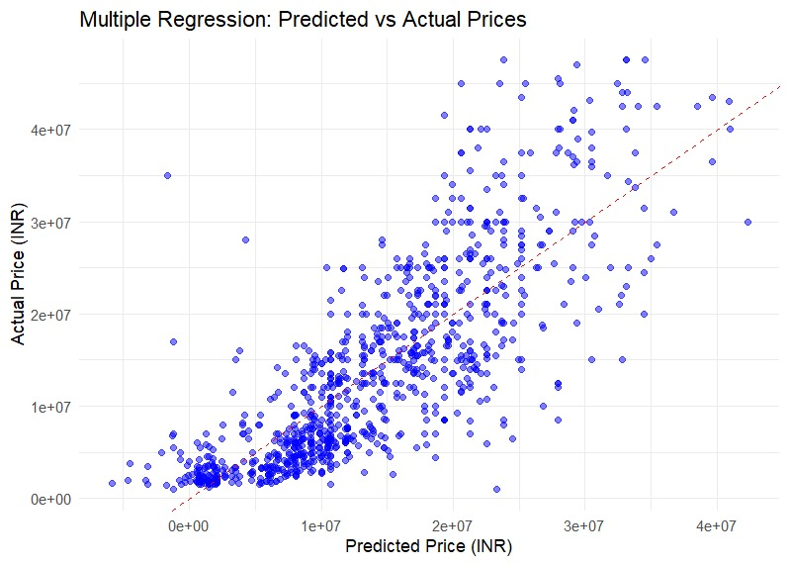
Fig.12.1:Multiple Regression :Predicted vs Actual Price
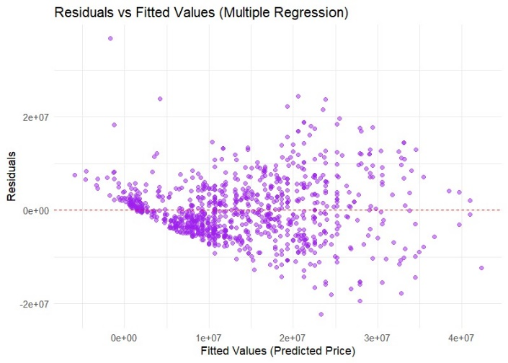
Fig.12.2: Residual vs Fitted Values
Interpretations from the Multiple Regression :
Area remains a key predictor but explains less variability than in the simple model.
BHK's negative coefficient suggests possible multicollinearity or structural issues.
Bathrooms significantly influence prices, highlighting their importance in valuation.
The model is statistically significant and improves predictions, though further refinement (e.g., addressing multicollinearity or adding predictors) is needed.
Figure 12.1: Predicted vs Actual Prices
Relationship: Points near the diagonal line (y = x) indicate good predictions, while deviations highlight inaccuracies.
Key Coefficients:
Intercept (-₹6,555,046): Baseline price; not meaningful in practice.
Area (₹13,038): Price increases by ₹13,038 for every 1 sq. ft. increase, holding other variables constant.
BHK (-₹1,465,336): Price decreases with additional bedrooms, possibly due to multicollinearity or less desirable locations.
Bathroom (₹4,213,954): Each additional bathroom significantly increases price.
Model Fit:
R-squared (0.6433): Explains 64.33% of price variability, an improvement from the simple model (Price ~ Area).
RSE (₹6,406,000): Indicates average deviation of predicted prices from actuals, slightly better than the simple model.

Figure 12.2: Residuals vs Fitted Values
Residual Patterns: Random scatter around zero suggests valid model assumptions. Patterns, if present, indicate heteroscedasticity or missing variables.
Residual Range: Residuals range from -₹22,278,341 to ₹36,675,702, suggesting potential outliers or unaccounted variability.

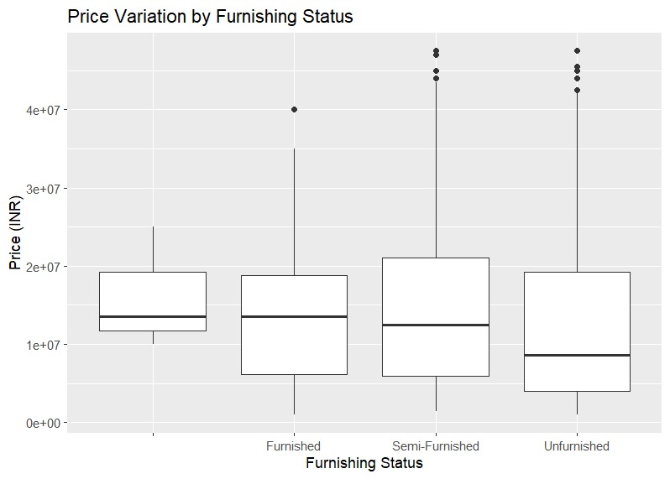

Fig. 13:Anova :Price Variation by Furnishing Status

Interpretation:Furnishing status (Furnished, Semi-Furnished, Unfurnished) does not significantly impact property prices. Variables like Area, Location, and BHK have a stronger influence and should be prioritized for analysis and predictions.
Sum of Squares: Furnishing explains 4.252e+14 of price variability, while residuals account for 1.077e+17, indicating most variability is unexplained by furnishing status.
Mean Square: Furnishing contributes 1.417e+14, comparable to the residuals (1.146e+14).
F-value (1.237): Low, suggesting minor differences in prices across furnishing categories.
p-value (0.295): High, indicating furnishing status does not significantly affect property prices.

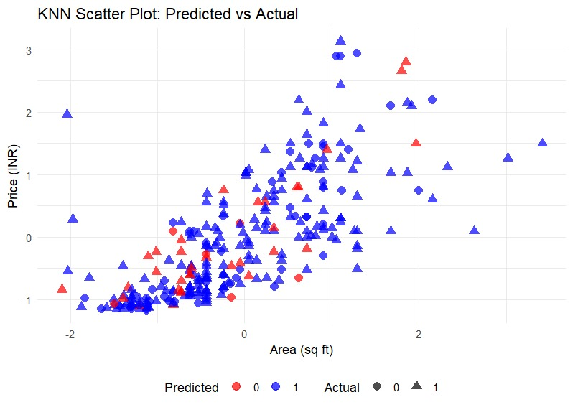
Fig.14 The KNN scatter plot compares Predicted Prices and Actual Prices for properties, evaluating the KNN model's performance in predicting property prices.
KNN Accuracy (69.37%): The model correctly predicts furnishing status (Furnished vs. Unfurnished) 69.37% of the time, which is reasonable given dataset variability.
Scatter Plot:
Red Triangles: Represent actual Unfurnished properties.
Blue Triangles: Represent actual Furnished properties.
Predicted Points (Circles): Close to the triangles, but some discrepancies appear, especially near the boundary between Furnished and Unfurnished.
Clustering: Furnished properties (blue) cluster in higher price ranges, while Unfurnished (red) properties are concentrated in lower price ranges.
Model Performance: The KNN model performs well for larger or higher-priced properties but struggles with those near the Furnished/Unfurnished boundary.

The KNN model shows moderate accuracy (69%), with reasonable predictions for larger properties but some misclassifications near the boundary between Furnished and Unfurnished. Further model tuning and additional features could improve predictions.

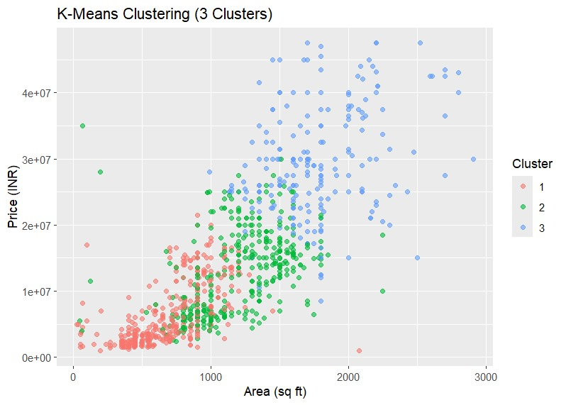
Fig. 15: K means clustering
K-means clustering successfully categorizes properties into three clusters based on Area (sq ft) and Price (INR), offering valuable insights into price and size segmentation, with opportunities for further refinement:

Red Cluster (Cluster 1): Small, affordable properties with lower prices.
Green Cluster (Cluster 2): Mid-range properties with moderate size and price.
Blue Cluster (Cluster 3): Larger, high-end properties with higher prices.
Key Insights:
Cluster Separation: The clusters are well-separated, with minimal overlap, showing clear segmentation based on size and price.
Price vs. Area: Larger properties generally have higher prices, confirming the typical real estate trend of larger homes being priced higher.
Cluster Insights:
Red: Small, more affordable properties.
Green: Mid-range properties, likely in suburban areas.
Blue: Large, high-end properties, possibly luxury homes.
Model Performance:
K-means effectively segments properties but could be further refined by exploring other clustering methods or adjusting the number of clusters using techniques like the Elbow Method.

Self-Organizing Maps
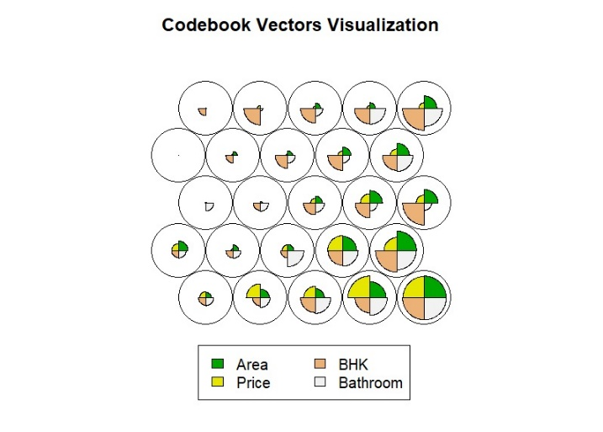
Fig. 16.1 Codebook Vectors Visualization
This plot shows the distribution of features (Area, Price, BHK, Bathroom) across the SOM nodes without hierarchical clustering boundaries.
Each node represents a set of data points, with the distribution of features displayed explicitly. This allows us to observe how individual features vary across the SOM grid. Since there are no cluster boundaries, we can directly compare how features (e.g., Area, Price, etc.) behave within each node, offering insights into their relationships across different segments of the dataset.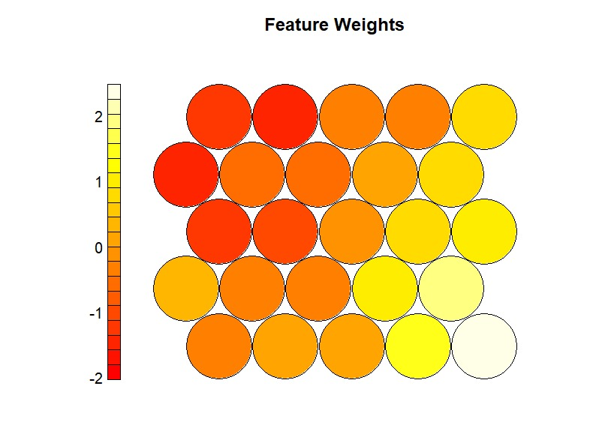
Fig. 16.2 Feature Weights Visualization
This visualization shows the contribution of individual features (like Area, Price, BHK) across the SOM grid, with a heatmap representing feature weights.
The heatmap shows the strength of each feature in each node. Bright yellow areas indicate nodes where a particular feature (e.g., Area or Price) has a strong influence, while red areas indicate nodes where the feature has low influence. This helps in identifying which features dominate in different parts of the dataset and their importance in the clustering process.
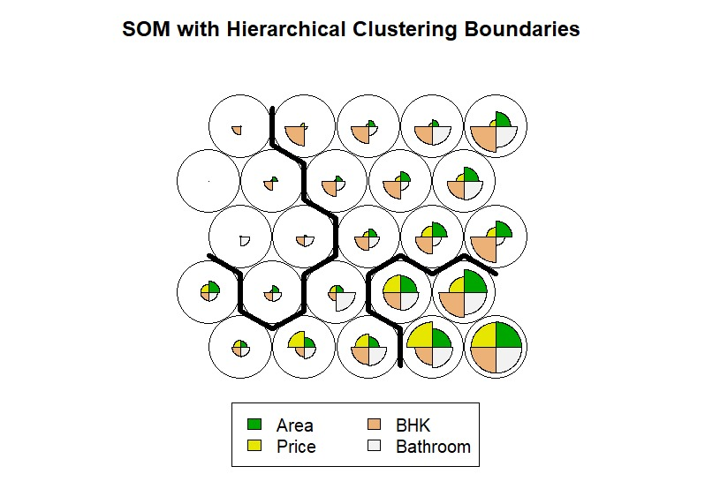
Fig. 16.3 SOM with Hierarchical Clustering Boundaries
This visualization combines SOM grid nodes with hierarchical clustering boundaries.
Each circular node represents a cluster of data points. Features such as Area, Price, BHK, and Bathroom are shown as segments within each node, highlighting their contribution to the cluster. Thick black boundaries divide the nodes into clusters identified through hierarchical clustering. This visualization helps in understanding how features are distributed within clusters and how distinct the clusters are in terms of their feature composition.
.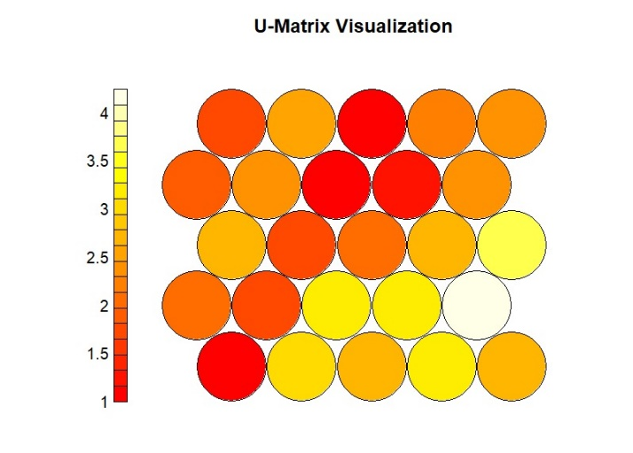
Fig. 16.4 U-Matrix Visualization
The U-Matrix measures the distances between neighboring nodes in the SOM grid.
The color gradient represents the distance between adjacent nodes. Darker colors (red) indicate areas where nodes are more dissimilar (i.e., belong to different clusters), while lighter colors (yellow) indicate areas where nodes are more similar (i.e., belong to the same or closely related clusters). This helps to identify regions of high dissimilarity (clusters) and areas where data points are more homogeneous (closer together in feature space).

- Discussion and Next Steps
The results derived in this dissertation provide understanding on the main issues affecting housing prices in Delhi city especially due to its increased urbanisation. Through exploratory data analysis (EDA) and predictive modelling the research clearly illustrates the extent of impact of characteristics like property area, number of bedrooms, number of bathrooms and locality on the prices of houses. Key analysis findings are that there was a significant relationship between the property area and the price as always bigger homes are likely to be more expensive. In a similar manner, the number of bedrooms and bathrooms is directly related to the price of the property since they are aspects that are likely to incorporate more space and more expensive investments. The case is further strengthened by this location factor because houses that are in hot neighbourhoods or near working areas are more expensive.
It was noticed in the observations that there was a bulk of the population contained properties in the mid-range value with the outliers being the high value or very low value population. The collated figures from the scatter plots and heat maps created during the analysis helped further in the conclusion that area and locality are the two major factors that determine the price of real estate in Delhi. The results found in this study correlate with previous researches which suggest that location and size of the property n the urban center is vital in the real estate market.
Next Steps:
ModelRefinement:Apply Random Forests, GBM, and XGBoost with hyperparameter tuning and cross-validation to improve accuracy.
Temporal Variables: Incorporate historical price trends and seasonal effects for better forecasting.
Spatial Analysis:Use geospatial features and spatial econometrics to assess location-based price impacts.
Feature Engineering: Enhance models with environmental and economic indicators (e.g., air quality, interest rates).
Advanced Techniques: Explore ensemble methods, deep learning, and NLP for deeper insights.
Real-World Applications: Provide insights for developers, homebuyers/investors, and policymakers to guide pricing, decision-making, and policy development.
- Conclusion
This research, House Prices: A Data-Driven Exploration with Descriptive and Predictive Analytics, offers valuable insights into the dynamics of the housing market in Delhi by integrating exploratory data analysis (EDA), descriptive statistics, and advanced predictive modeling techniques. By combining classical statistical methods and machine learning algorithms, the study has successfully identified key factors influencing property prices in the city.
The research addressed the central question of what drives house prices in Delhi, focusing on critical variables such as location, property size, number of rooms, furnishing status, and transaction type. Through rigorous data preprocessing and analysis of a comprehensive dataset from Kaggle, the study revealed key trends and patterns that highlight the complex interplay of these factors in determining property prices. Notably, area and locality emerged as the most significant determinants, with larger properties commanding higher prices and premium neighborhoods, such as South Delhi, showing consistently higher valuations.
In addition, variables such as the number of bedrooms (BHK) and bathrooms were found to directly influence property prices, demonstrating buyer preferences for spacious, well-equipped homes. The analysis of price distribution revealed a right-skewed pattern, with most properties falling within mid-range values, while high-end and budget properties formed the outliers.
Predictive modeling further enhanced the study's findings. Multiple linear regression models demonstrated how factors like area and locality could explain price variations. K-Means clustering segmented the market into affordable, mid-range, and luxury properties, while Self-Organizing Maps (SOM) and KNN classification provided deeper insights into high-dimensional relationships and property categorization.
This research has practical implications for homebuyers, investors, real estate developers, and policymakers. Homebuyers can make more informed decisions, developers can align projects with market demand, and policymakers can address housing affordability and ensure equitable access. Future research should explore temporal and geospatial variables and incorporate advanced machine learning techniques to further enhance prediction accuracy and offer even more actionable insights for the real estate market.
References
[1] V. Chiarazzo, L. Caggiani, M. Marinelli, and M. Ottomanelli, “A Neural Network based Model for Real Estate Price Estimation Considering Environmental Quality of Property Location,” Transportation Research Procedia, vol. 3, pp. 810–817, Jan. 2014, doi: 10.1016/j.trpro.2014.10.067.
[2] N. Kok, P. Monkkonen, and J. M. Quigley, “Land use regulations and the value of land and housing: An intra-metropolitan analysis,” Journal of Urban Economics, vol. 81, pp. 136–148, Apr. 2014, doi: 10.1016/j.jue.2014.03.004.
[3] Manganelli, B., & Izzo, F. (2018). Real estate appraisal: A computational approach using multiple regression and decision trees. Springer. https://doi.org/10.1007/978-3-319-76204-8
[4] P. F. Smith, S. Ganesh, and P. Liu, “A comparison of random forest regression and multiple linear regression for prediction in neuroscience,” Journal of Neuroscience Methods, vol. 220, no. 1, pp. 85–91, Sep. 2013, doi: 10.1016/j.jneumeth.2013.08.024.
[5] S. Rosen, "Hedonic prices and implicit markets: Product differentiation in pure competition," J. Polit. Econ., vol. 82, no. 1, pp. 34–55, 1974.
[6] N. Kok, M. Kahn, and P. Eichholtz, "Big data in real estate: From manual appraisals to automated valuation models," J. Urban Econ., vol. 123, pp. 108–121, 2017.
[7] E. Hromada, "Use of data mining for real estate valuation," Int. J. Eng. Bus. Manag., vol. 8, no. 2, pp. 67–78, 2016.
[8] M. Geerts, J. de Wit, and P. Armitage, "Survey of house price prediction methods," J. Prop. Invest. Fin., vol. 41, no. 3, pp. 247–258, 2023.
[9] J. Hong, "Advanced machine learning techniques in real estate: Boosting algorithms for price prediction," J. Comput. Sci., vol. 56, pp. 209–221, 2020.
[10] G. Louppe, "Understanding random forests: From theory to practice," J. Mach. Learn. Res., vol. 15, no. 1, pp. 101–128, 2014

